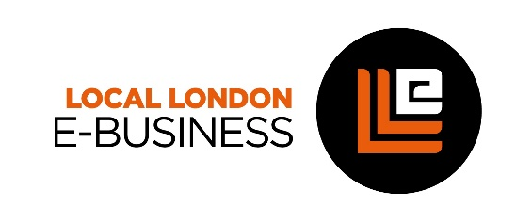
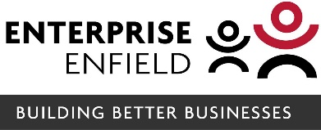

E-business Programme
Digital technology has had a massive impact on businesses and is rapidly changing everything from marketing and customer communications to business operations and processes. Business owners’ ability to understand and apply digital technology within their business is becoming more and more crucial to boosting productivity and increasing competitiveness.
The E-business Programme is a free programme, delivered by Enterprise Enfield and supported by Local London, which is designed to help small and medium sized business owners engage with and understand how to use digital technology to enhance their online presence; improve efficiency; attract more customers; enhance their sustainability and future growth. 1,650 SMEs in Enfield, Waltham Forest and Redbridge will be assisted over the next 3 years (commencing in October 2021).
​About the programme
The programme offers participants access to a Business Adviser and Digital Expert – as well as a range of workshops and webinars – to help them get to grips with digital tools and technology to:​
- Boost their business sales and customers
- Enhance their business online presence
- Maximise website search engine ranking (SEO)
- Harness the power of email marketing and social media
- Understand how to use online sales platforms
- Tap into new sales with ecommerce / online payments
- Improve customer service and Customer Relationship Management (CRM)
- Learn how to use e-accounting to improve their business efficiency
- Find safer data security and back up systems
How does it work?
Business owners will be invited to an initial meeting with a Business Adviser (either in person or via zoom) - who will identify the business's current use of technology and digital tools. This Digital Audit meeting will identify how the business is operating currently - including IT processe, website, customer relationship management systems, social media, email marketing, e-accounting, e-commerce, online payment systems, data security, back-ups and use of any online sales platforms.

​Together with the Business Adviser, this meeting will help to create a bespoke Digital Business Plan which will include details of the actions needed to be taken to maximise and improve the business’s digital marketing / operations. Following the meeting the business will have access to a Digital Expert who will help the owner implement the key actions identified in the plan, through regular follow up meetings.

Throughout the period of the Programme both the business owner and any of their employees, will have FREE access to the programme’s e-business workshops and webinars. Topics will cover a range of areas including: e-commerce/ online sales platforms; email marketing; social media; customer relationship management systems (CRM) etc.

Eligibilty
To be eligible to enrol on this programme owners must be running a business which:​ has a 6-month trading history; is located in one of the following boroughs: Enfield, Waltham Forest or Redbridge and has fewer than 251 employees.

